AWS Trupti Desai

- EC2 in N.Virginia Launched
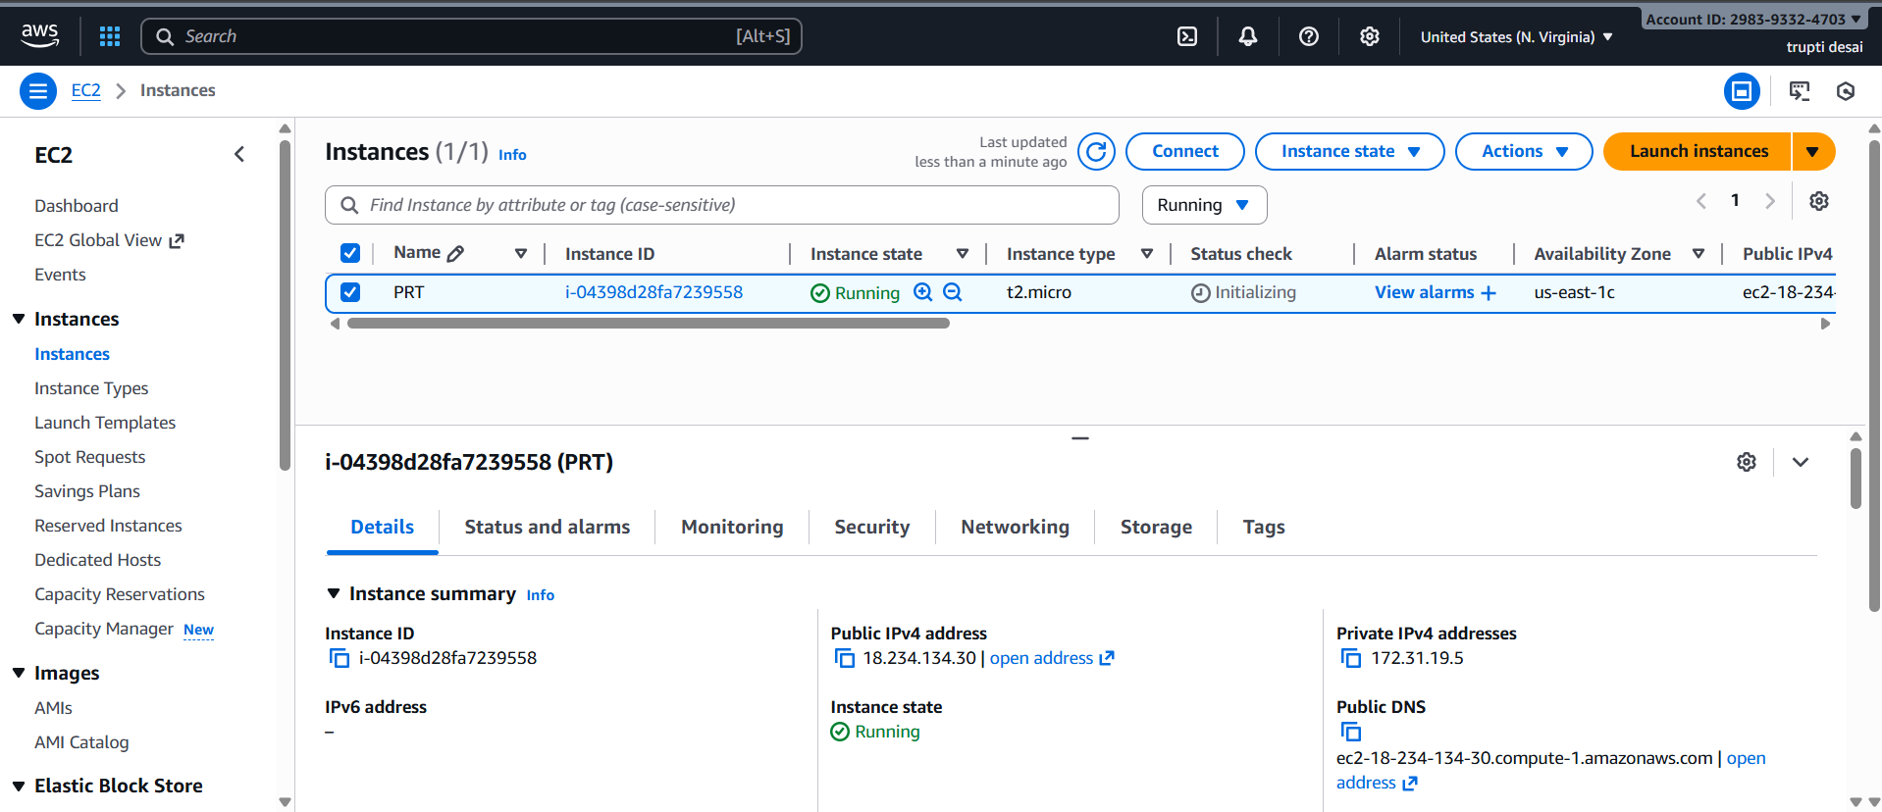

2. Connected
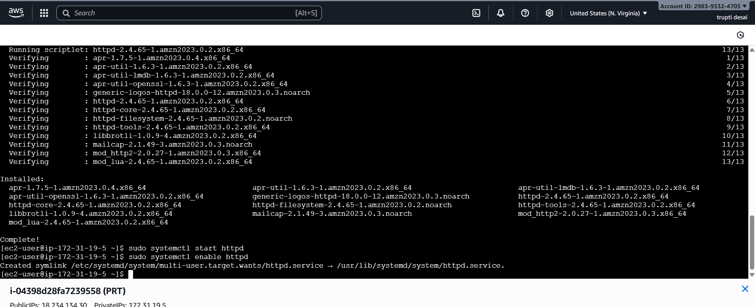

3 Apache server installed on EC2 n.Virginia
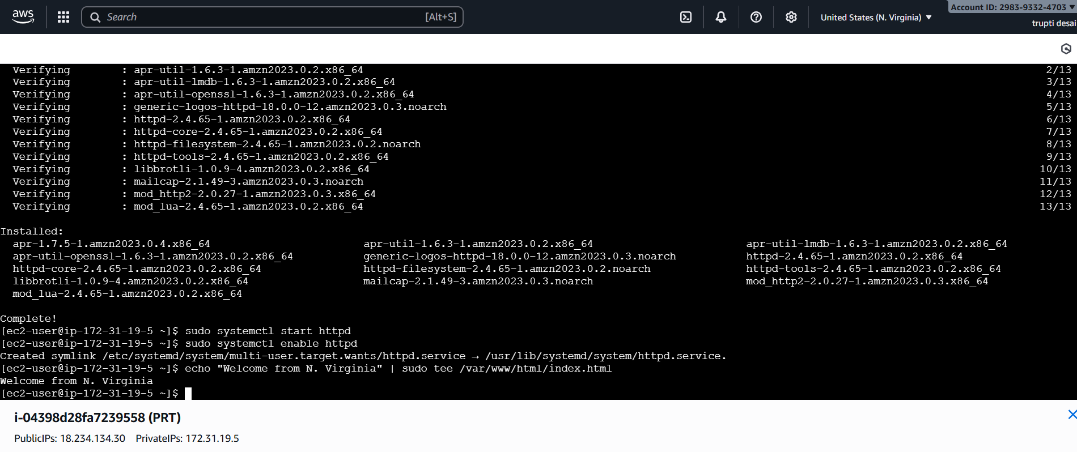
4 Changed index.html and output shown on browser
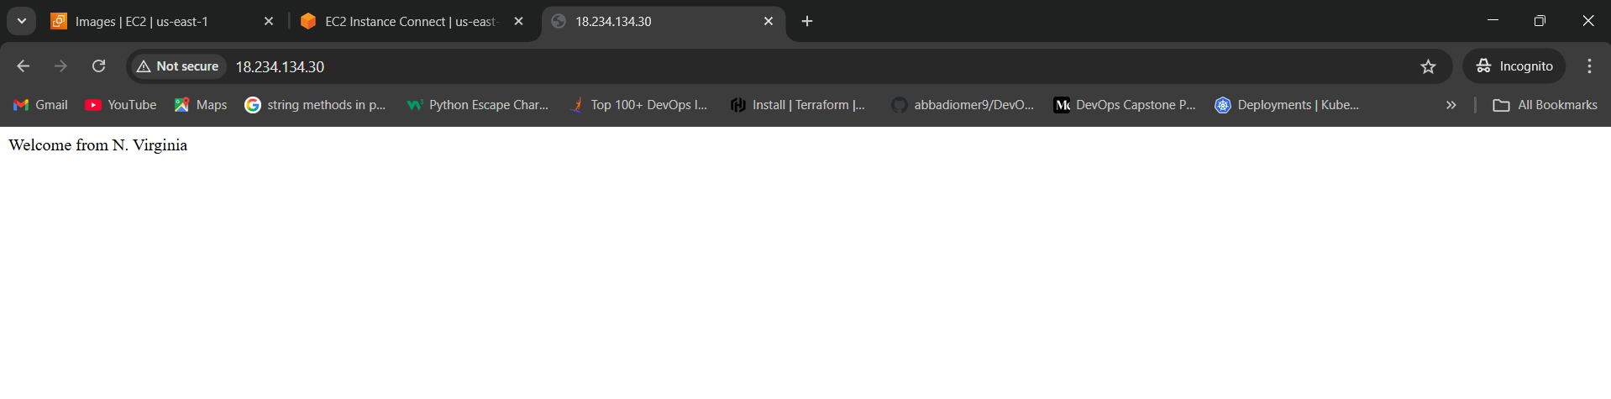

5 AMI created from EC2 N.Virginia
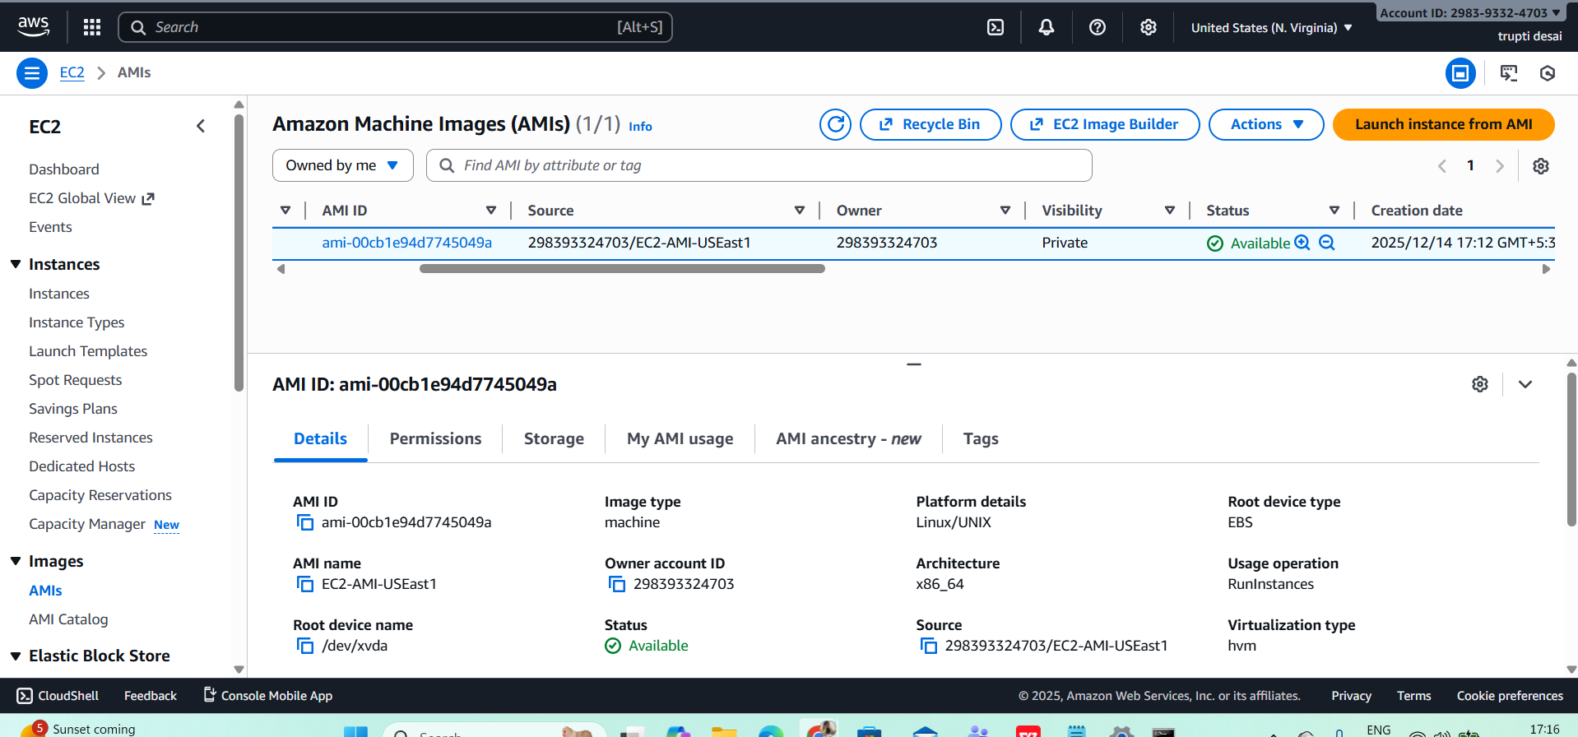

6 Copied that AMI to Mumbai region
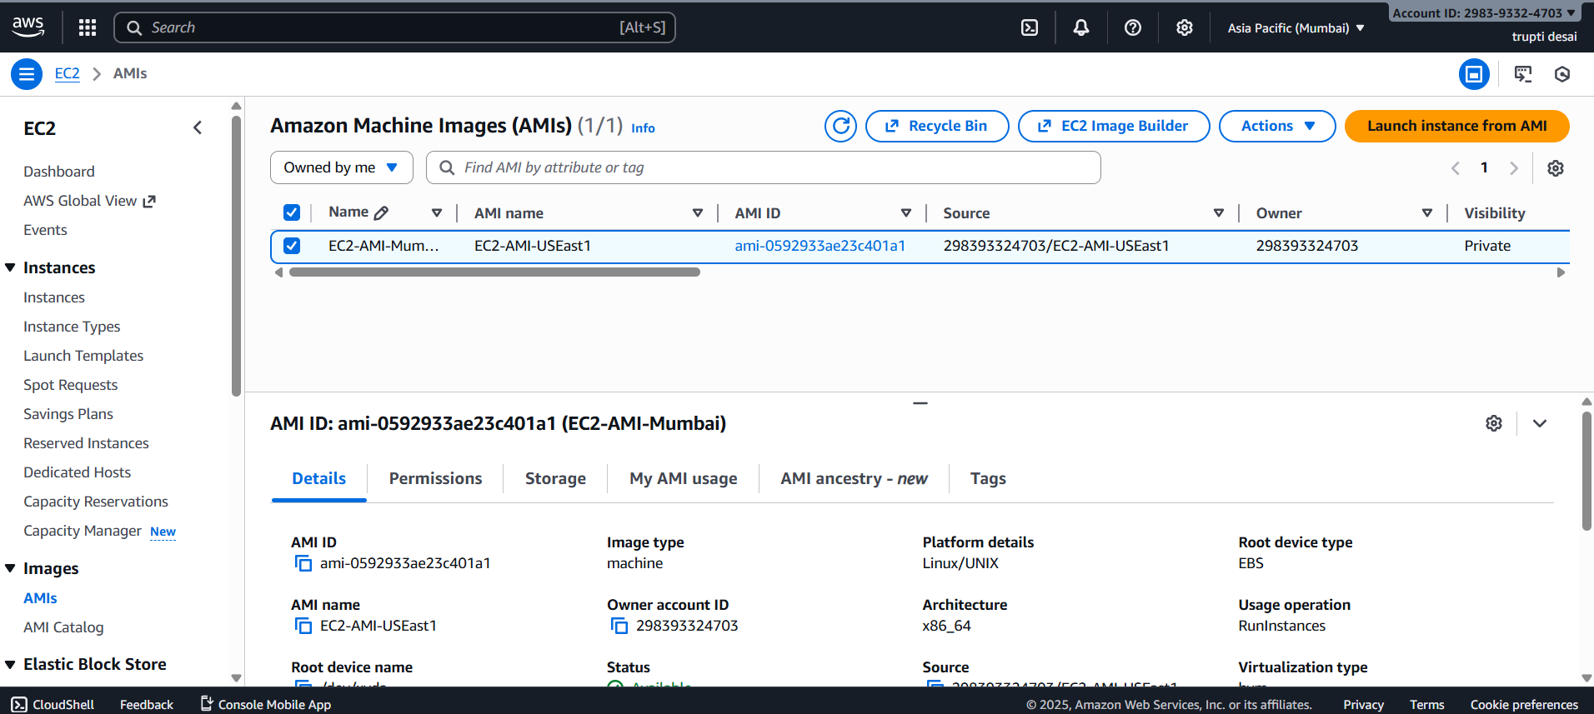

7. EC2 created from AMI that copied
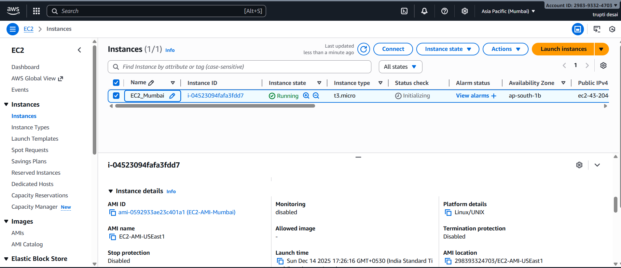

8 changed index.html
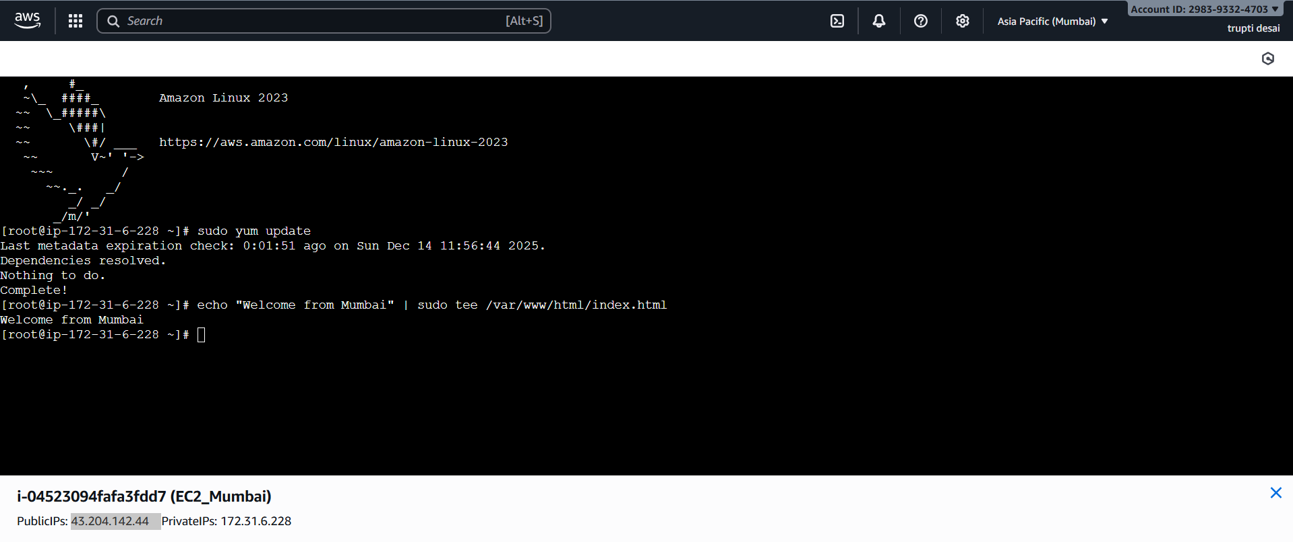

9. Output on Browser
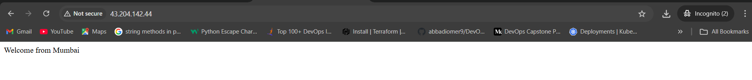

10 Global Accelerator configuration
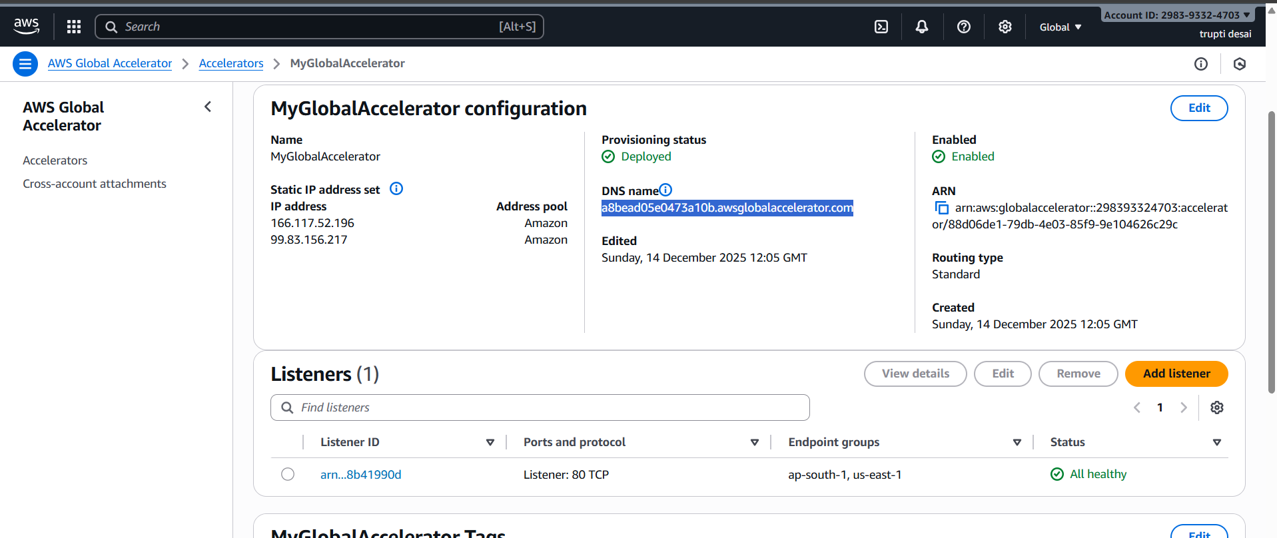

11.
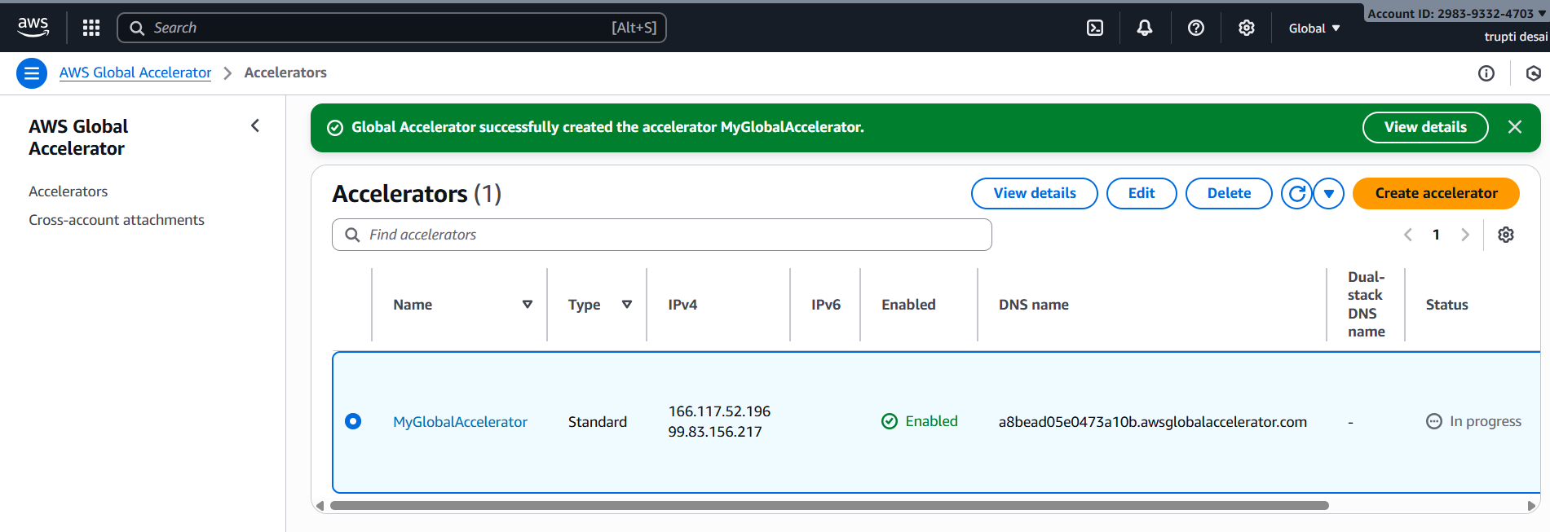

12 Browser responses from nearest region
